Candidate Preparation Document

Teaching & Coaching Instructor Interview - Full-Stack Program

* Congratulations on making it to our Teaching and Coaching Interview! The goal of this document is to set you up for success as much as possible by giving you all the information you need to put your best foot forward during the interview.

# Interview format

## Medium

* The interview will be conducted over Zoom.
* You will be expected to be on camera. The meeting will be recorded.
* The interview recording will be shared with our University partners for approval. Since, if everything goes well, you will be representing our University partners as well, we encourage you to have on a professional attire during the interview.
* You will be expected to share your screen. If you haven’t used Zoom before to present, check out [this YouTube video](https://www.youtube.com/watch?v=QOUwumKCW7M&t=520s).

## Interview setup

Assume that another instructor has been teaching this class until now. During your interview, assume that you are a substitute instructor for that day. The students haven’t met you before.

## Lecture expectations

Do NOT worry about covering everything in the slide deck within the 15 minutes allocated for the lecture. Just pace yourself and cover what you can while making sure that your students are comprehending the material. During this interview, we will be more interested in how you deliver the material than whether you covered everything in the slide deck.

## What we will be looking for

For you to get to this stage, you’ve already passed our Tech Interview. Therefore, during this Teaching and Coaching interview, we are more interested in observing how you deliver the lesson and how engaging you are with the students than whether you can read us the slides. Remember that our classes will be running after work hours and our students will be exhausted after their work day. Bring enthusiasm and energy that students can latch on.

# Interview timeline (60 min)

## Part 1: Lecture

* 15 min of lecture
* 5 min of lecture feedback
* 1-3 min of absorbing the feedback
* 7 min of lecture applying the given feedback

## Part 2: Coaching

* 15 min of coaching students on how to overcome being stuck with their code
* 15 min of closing remarks & answering your questions

# What you should have

You should have received from your recruiter a folder with 5 files inside of it (including this one). Double check and make sure that you have the following files in that folder:

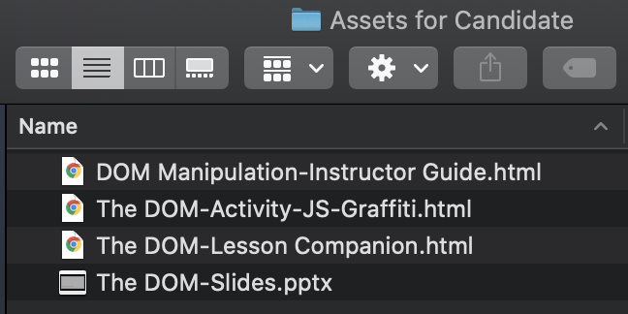

Contact your recruiter right away if any of the above files is missing from your folder.

# Overview of each file

## DOM Manipulation-Instructor Guide.html

Each one of our courses has an Instructor Guide. The Instructor Guide is meant to give our instruction staff insights about the structure and content of the course. As shown in the picture below, the Instructor Guide also provides our instruction staff with information on how to manage each class, showing the estimated amount of time each part of the lesson will take, along with the assets that will be used for instruction (Slides, Activities, etc.).

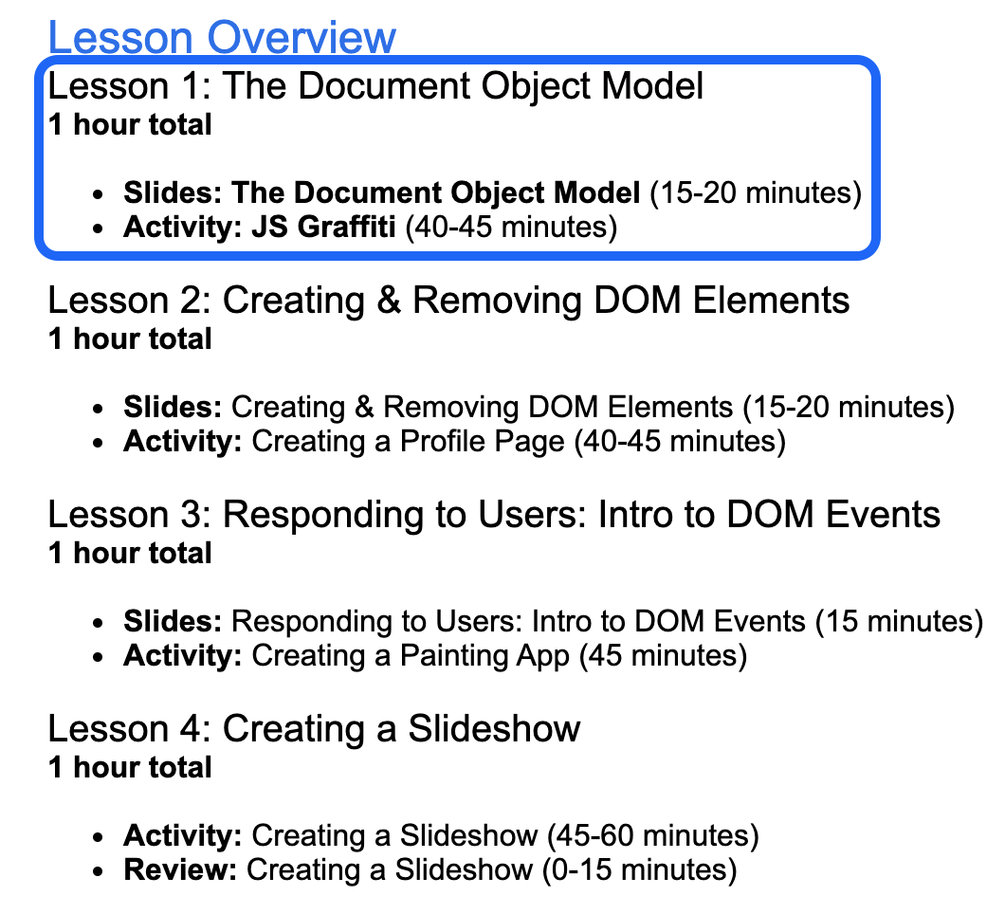

Opening the **DOM Manipulation-Instructor Guide.html** file using the Google Chrome browser reveals an overview of the DOM Manipulation course. The DOM Manipulation course is made of 4 lessons. During the Teaching & Coaching Interview, you will get to teach us a part of the lesson above (Lesson 1: The Document Object Model) in a simulated classroom**.**

Before each lesson, we expect our instruction staff to read the Instructor Guide to familiarize themselves with the lesson they will teach. Therefore, use the **DOM Manipulation-Instructor Guide.html** file to prepare yourself for the Teaching & Coaching Interview with us.

## The DOM-Slides.pptx

Each one of our lessons has slides for the instructor to use during class to teach students that lesson. Opening **The DOM-Slides.pptx** file using either Microsoft PowerPoint or Keynote reveals a slide deck for **Lesson 1: The Document Object Model**. During the Teaching & Coaching Interview, you will use these slides to teach us about the Document Object Model in Javascript.

Each slide is intended to facilitate your oral presentation to the students. Avoid the temptation to just read the slide's text aloud. The ideal instructor does not read off the slides verbatim. Instead, they use the slides as pivot points to instill an idea , spark an engaging class discussion, elaborate on a concept, and/or provide extra context from their experience. For that reason, you will find speaker notes on most slides for some ideas to spark engagement with the students. Below is what a slide with speaker notes will look like. (Speaker notes are off by default in Keynote. Use [these directions](https://support.apple.com/guide/keynote/add-and-view-presenter-notes-tand1a4ee7c/mac) to turn them on)

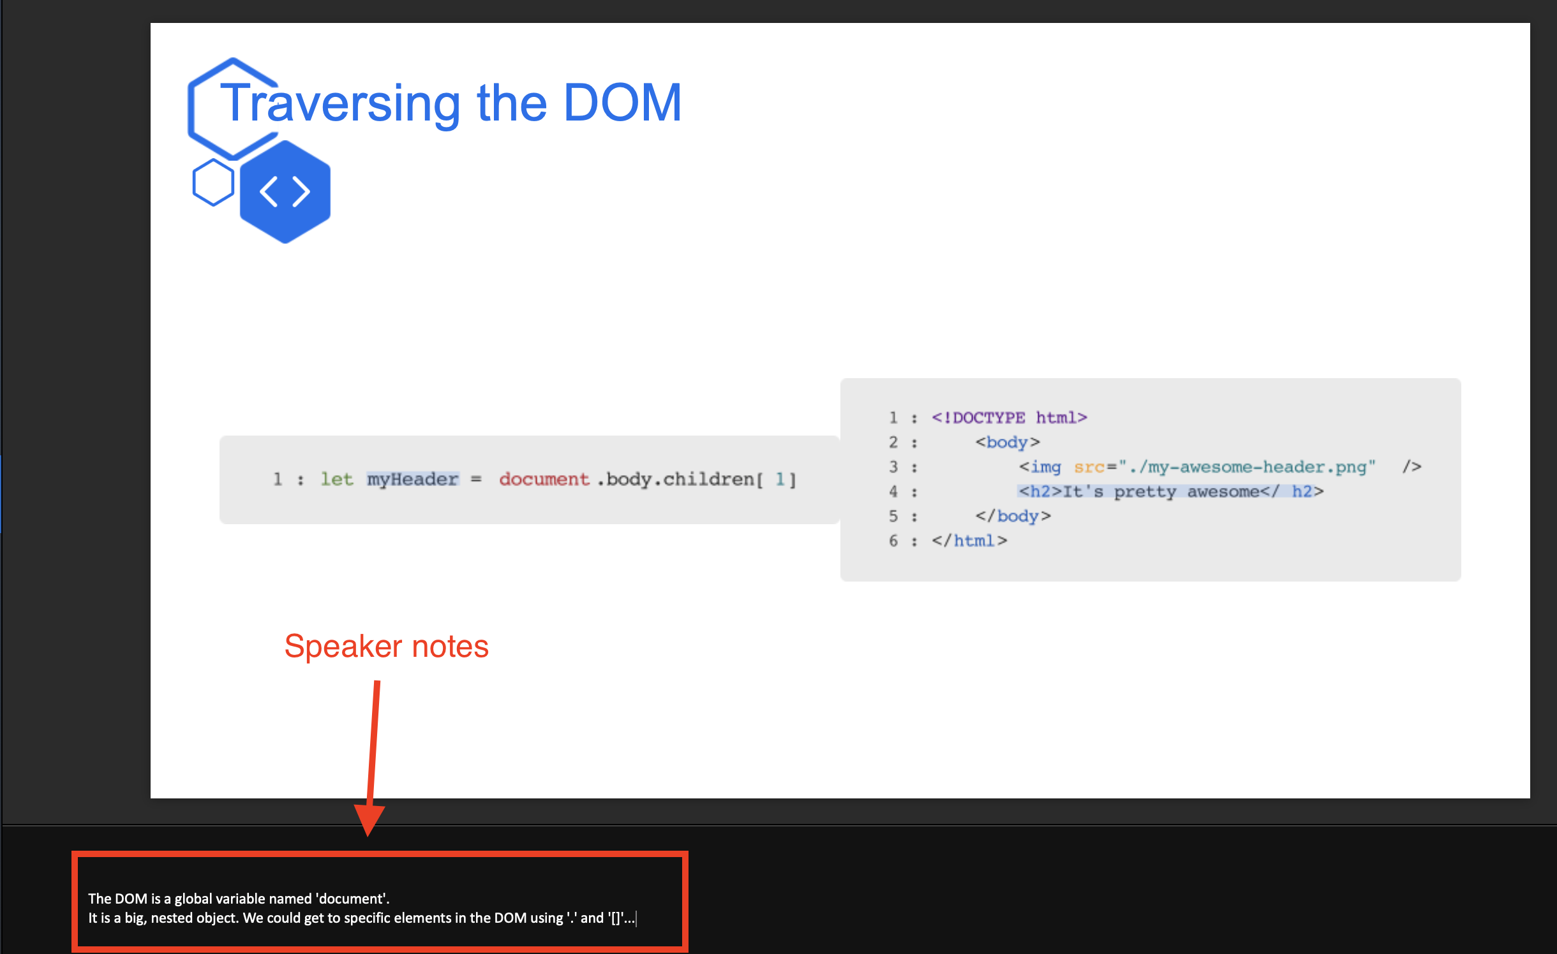

NOTE: There is a mistake in the slide you will be using to teach us during the Teaching and Coaching interview. The mistake was put there on purpose to simulate a real scenario during which there might be a mistake or bug in our curriculum. In such a case, we expect the ideal instructor to report the mistake to our Instructor Readiness Team to make sure that our curriculum gets updated with the right information. Because we use a semi-automated publishing process, just changing the material the instructor has on-hand to correct the mistake or bug is not a permanent “fix”. Doing that will result in the same mistake or bug being reintroduced in the curriculum the next time there is an update. Hence, the need for the instructor to report the mistake or bug to us and have our Curriculum Engineering team fix the mistake or bug on the backend. If the change from our Curriculum Engineering team cannot be merged into the curriculum in time before teaching that lesson, the ideal instructor will make the necessary changes to the asset they have so that we don’t present wrong information to the students.

Before the Teaching & Coaching Interview, use this link (<https://forms.gle/MkuqzJ1DYXot4cW7A>) to report the error you find in the slides you have. During the Teaching & Coaching Interview, we expect you to have fixed that error in the slides you will present to us.

## The DOM-Lesson Companion.html

Each one of our lessons has a Lesson Companion Guide for the students to use simultaneously with the instructor’s lecture slides. The Lesson Companion Guide is an interactive fill-in-the-blank style coding exercise to help students follow along with during the instructor lecture.

Some slides have a Lesson Companion Guide cue icon in their top-right hand corner to indicate to both the instructor and the students that there is an interactive exercise in the Lesson Companion Guide directly related to the material covered in that specific slide. In other words, after covering the material in that slide, students should be able to work on that interactive exercise in the Lesson Companion Guide. Below is how a slide with the Lesson Companion Guide cue icon looks like.

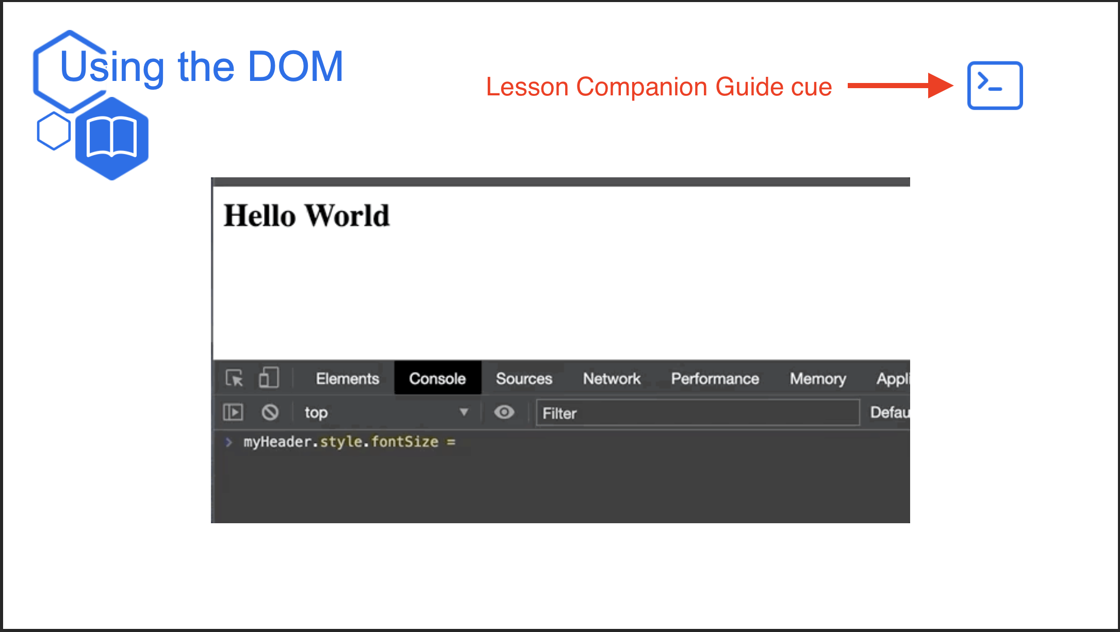

We leave it to our instructor to use their discretion and judgement on how to incorporate the Lesson Companion Guide into the flow of their class. We are looking forward to seeing how you use the companion guide with the slides you will teach us during the Teaching & Coaching Interview.

Part 2 of the Teaching & Coaching Interview, will involve you helping students get unstuck with code from the above Lesson Companion Guide.

## The DOM-Activity-JS-Graffiti.html

Some of our lessons have a hands-on in-class activity that students get to do to practice and solidify what they learned in those lessons. Opening **The DOM-Activity-JS-Graffit.html** file using the Google Chrome browser reveals the activity your students will use to practice what they would have learned during your lecture do to solidify their understanding of using the Document Object Model in JavaScript. Some activities will be done in groups and some will be done individually. This one will be done individually by each student. This activity is purely for your reference and will not be part of the Teaching & Coaching Interview. However, we encourage you to go through it before the Teaching & Coaching Interview to get an idea of what your students would be able to do after your lecture in a real classroom. We believe that having that context will improve the quality of your lesson delivery.

# What you can expect

## Students level

During the Teaching & Coaching Interview, you can expect your students to have covered the following courses before the DOM Manipulation lesson:

* **Intro to HTML**, from which students should be able to:
  + Describe the format of an HTML document
  + Name several common HTML tags including for links, images, and text
  + Tell the difference between tags, their attributes, and their content
* **Styling with CSS**, from which students should be able to:
  + Include CSS from an internal or external stylesheet
  + Use CSS selectors to selectively apply styles to elements in the DOM
  + Describe and use the box model
* **Git & Github**, from which students should be able to:
  + Tell the difference between Git and Github
  + Use Git commands to track their own work and to contribute work to a project
  + Publish websites on Github Pages
* **Programming with JavaScript**, from which students should be able to:
  + Create short bits of functional code with JavaScript
  + Construct conditional statements and loops
  + Evaluate boolean expressions and truthiness/falsiness

We hope that this document is helpful to you as you prepare for your Teaching & Coaching Interview with us. We are looking forward to having you teach us and we wish you all the best!

The Instructor Readiness Team @ HackerU